Title: Supportive learning.

**Background**

Supportive learning is a system like a course management system, when students can upload the project/assignment/lab to the system, also can see the result. Let’s do the user site of website.

**Program Specifications**

Program a supportive learning, detail functions of this website is described below

**Features:**

This website contains 05 (six) main functions

* Function 1: Home page  ( see figure 01)
* Function 2: Login page  ( see figure 02)
* Function 3: Upload assignment page (see figure 03)
* Function 3: View assignment mark page (see figure 04)
* Function 5: FAQ page (see figure 05)

Note: All data must be load from database, not hard code.

***Expectation of User interface:***

Pic 01: Home Page ( TOP)



PIC 02: Login Page

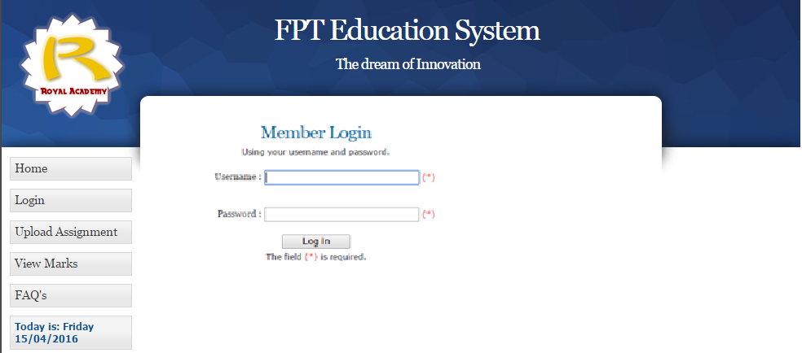

Pic 03: Upload assignment Page

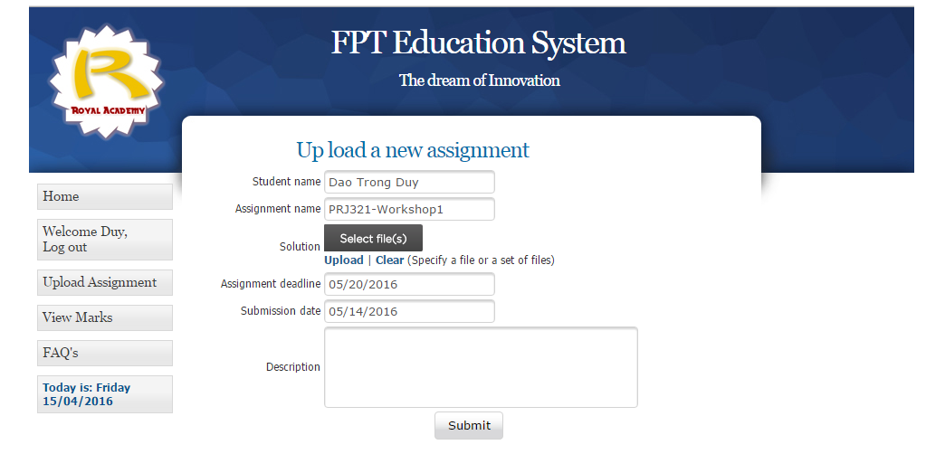

Pic 04: View assignment mark Page

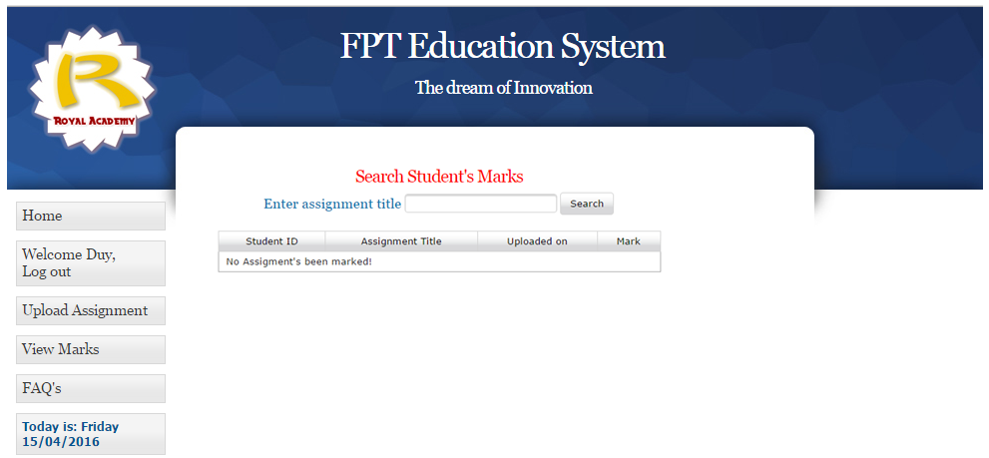

Pic 05: FAQsPage

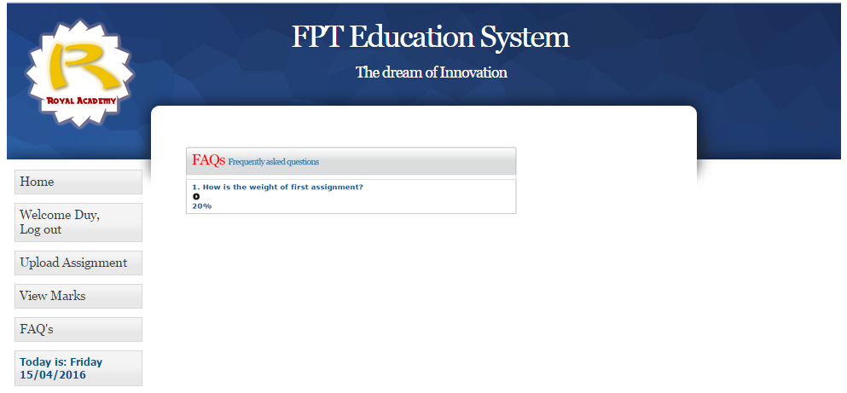

**Title: Supportive learning – Admin site**

**Background**

Supportive learning is a system like a course management system, when students can upload the project/assignment/lab to the system, also can see the result. Let’s do the admin site of website.

**Program Specifications**

Program a supportive learning, detail functions of this website is described below

**Features:**

This website contains 04 (six) main functions

* Function 1: Login page  ( see figure 01)
* Function 2: Student assignment page (see figure 02)
* Function 3: Assignment management page (see figure 03)
* Function4: FAQ management page (see figure 04)

Note: All data must be load from database, not hard code.

***Expectation of User interface:***

Pic 01: Login Page ( TOP)

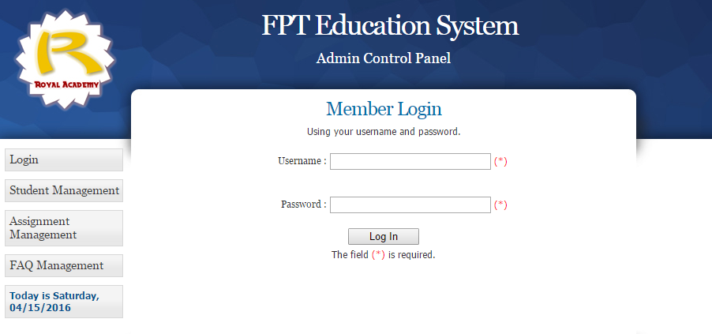

PIC 02: Student management Page

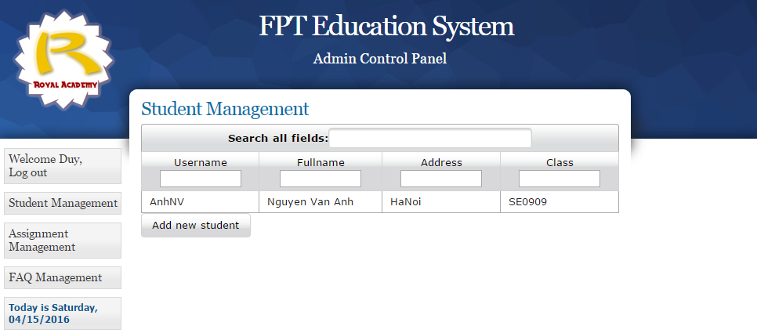

Pic 03: Assignment management Page

*Note: Students can add a radio column to select the row they want to update, when they click the save button it update the selected row*.

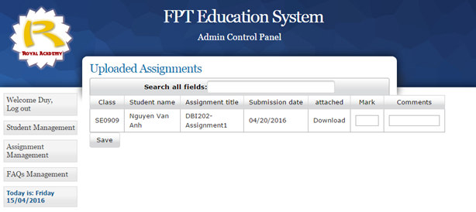

Pic 04: FAQ management Page

